# Table of Contents

Foreword

Statement from the Alliance of Independent Authors:

Disclaimer

Table of contents

1. What is eBook accessibility?

Key terms in the process

2. How eBook accessibility works and for whom

Visual Impairment

Dyslexia

Blindness

Physical disabilities

3. Factors which influence eBook accessibility

4. Constructing an accessible source document

Applying Styles

Character formatting

Image accessibility

Text as graphics should be avoided

Avoid using tables

5. Introduction to eBook formats and accessibility support

EPUB

Kindle

Adobe PDF

EBooks as dedicated Apps

6. Accessibility in self-publishing retailers

Amazon Kindle Direct Publishing

EBook format and features

Accessibility advice

Reading System accessibility

Issues and workarounds

Apple iBooks

EBook format and features

Accessibility advice

Reading system accessibility

Issues and workarounds

Barnes & Noble Nook Press

EBook formats and features

Accessibility advice

Reading System accessibility

Issues and workarounds

Kobo Writing Life

EBook formats and features

Accessibility advice

Reading system accessibility

Issues and workarounds

7. Accessibility challenges

Complex content

Interactivity

Multimedia

8. Additional Considerations

Digital Rights Management

Fixed layout

9. Checklist of accessibility considerations when self-publishing

10. Glossary of terms

11. Further resources

Accessible Publishing

Manuscript Document Formatting

Image descriptions

Reading System Accessibility

EBook format accessibility

Manuscript formatting

12. Image credits

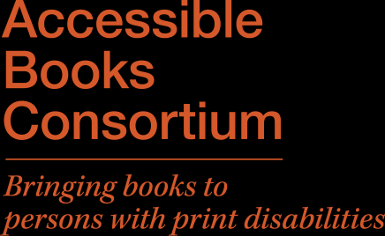





Accessible eBook Guidelines for

Self-Publishing Authors

Written by Dave Gunn

Published by the Accessible Books Consortium, in conjunction with the International Authors Forum.

January 2016

Foreword

No matter if you are thinking of self-publishing your first book or you are a seasoned author with existing publications, this guide is designed for you. It will introduce you to the ways people with print disabilities like sight loss, dyslexia or a physically limiting disability can read using eBook technologies. It will highlight some of the potential challenges and walk you through the steps you can take to make your next publication more accessible to this global audience of people with print disabilities. An estimated one billion people worldwide have some form of disability, many of whom will be unable to read conventional publications. There are so many people in this group that you probably have friends or family members who are unable or struggle to read conventional print.

More importantly, as globally people are living longer, the ageing population is predicted to significantly increase the number of people with print disabilities. By considering accessibility in the self-publication of your eBook, you not only help to create a more equal world for people with print disabilities but you also enable a much wider population to enjoy the result of your work.

In this guide you will:

•  Be introduced to the key terms and concepts in eBook accessibility

•  Understand how people with print disabilities can read eBooks

•  Discover how to create a manuscript which supports accessibility

•  Learn about accessibility in the major eBook formats

•  Explore how the primary self-publishing retailers support accessibility

•  Investigate some of the challenges in accessible eBook publishing Towards the end of this guide a checklistis provided for you to work through the key accessibility considerations for your publication, reviewing the key points made throughout the document.

Statement from the Alliance of Independent Authors:

The Alliance of Independent Authors (ALLi) is delighted to support the International Authors Forum (IAF) and the World Intellectual Property Organization’s (WIPO) Accessible Books Consortium (ABC) initiative, raising awareness of the very important issue of eBook accessibility for persons with print disabilities - far too easily overlooked or misunderstood by indie authors/author publishers focusing on the mainstream market. These clear and practical recommendations will make them realise how easy it would be to make their eBooks more accessible, greatly increasing the range of books available in appropriate formats for people unable to read standard print and, at the same time, boosting their potential readership substantially. It is a win-win scenario.

Disclaimer

All reasonable precautions have been taken to verify the information contained in this publication.

However, the published material is being distributed without warranty of any kind, either expressed or implied.  The responsibility for the interpretation and use of the material lies with the reader.  In no event shall the author, the Accessible Books Consortium or the International Authors Forum be held liable for any consequences of its use.

2

Table of contents

1. What is eBook accessibility? ............................................................................................................... 3

2. How eBook accessibility works and for whom ................................................................................... 4

3. Factors which influence eBook accessibility ....................................................................................... 7

4. Constructing an accessible source document ..................................................................................... 8

5. Introduction to eBook formats and accessibility support................................................................. 12

6. Accessibility in self-publishing retailers ............................................................................................ 13

7. Accessibility challenges ..................................................................................................................... 16

8. Additional Considerations ................................................................................................................. 17

9. Checklist of accessibility considerations when self-publishing ......................................................... 18

10. Glossary of terms ............................................................................................................................ 19

11. Further resources ............................................................................................................................ 20

12. Image credits ................................................................................................................................... 21

1. What is eBook accessibility?

Anyone authoring a book would like it to be read and enjoyed by the widest possible audience. For many people this is simply a matter of awareness and personal preferences. However, people with print disabilities have historically been exposed to a much more restricted catalogue of titles. Just a few years ago, fewer than 5% of publications in the western world were available in an accessible format like braille, large print or audio, and fewer still were available in a more flexible digital format. At the same time, in developing countries, it was estimated that fewer than 1% of publications were available in any accessible formats, resulting in a significant barrier to education and social inclusion.

EBook technologies have opened up an array of new opportunities for people with print disabilities to gain equal access to the same publications as their peers without delay and with no dependence on the limited resources of charitable organisations. EBooks have the potential to be enjoyed by everyone irrespective of disability and this can often be achieved very simply.

Key terms in the process

Because eBooks are still a relatively new technology for many people, the terms used in the publication process can become confusing, especially those terms which can be used interchangeably based on context. For clarity, the following terms will be used throughout this document.

•  Author Publisher: the person who created the original Work which they would like to publish, and also in this process the person who has a formal relationship with an eBook Retailer to make the book available.

3

•  eBook Retailer: the technology company which establishes a formal relationship with the Author Publisher, accepting their Work in a digital form, automatically converting it and making it available through their eBook shop.

•  Intermediaries: an optional third-party organisation which offers to work on behalf of an Author to process and submit their Work to an eBook Retailer, managing the technology and assisting with establishing the relationship.

•  Reading System: because the term “eBook reader” can confusingly refer to both a user and the piece of technology rendering an eBook, the industry has adopted the term Reading System to reference a tool used to access and navigate the eBook. This could be a conventional piece of software for a desktop computer, an App for a smart phone or tablet, or a dedicated piece of technology. All the major Retailers have their own dedicated Reading Systems which have to be used to access their eBooks.

•  User: the customer of the Retailer who buys the eBook and reads it on their Reading System of choice. In the context of this document, this user is a person with a print disability and the Reading System may need to have special qualities for the eBook to be accessible.

The Glossary of termstowards the end of this document offers a reference resource and additional descriptions for phrases used throughout this document.

2. How eBook accessibility works and for whom

The essence of eBook accessibility relates to supporting flexible ways for people to engage in the eBook content based on their personal needs. The adage of “no one size fits all” is particularly true of people with print disabilities accessing eBooks or any reading material and one of the strengths of eBook technologies is to allow users to quickly and easily customise the way the content is presented to suit their requirements.

Some of these customisations come by default in all reading systems and some are more specialist requiring additional equipment to be achieved. Developments in portable mainstream devices like tablets and phones have resulted in affordable equipment capable of supporting a diverse range specialist needs. If you have a modern smart phone or tablet, you may be surprised that the device you regularly use can offer life changing access to eBooks for people with a variety of print disabilities.

Visual Impairment

For individuals with low vision, control over the way text is presented is essential. Many people with a visual impairment may simply need to enlarge the size of the text before they can read it and, in some cases, this can mean increasing the scale so only one or two words fit on the screen at a time.

In conjunction with text size, some people with a visual impairment also benefit from being able to change the typeface and, while there is limited evidence to indicate a single preferential typeface over another, research does suggest people with a visual impairment find reading much easier with a typeface of their choice. People with certain eye conditions also benefit from increasing the contrast of the text from the background, with yellow and black being a common colour combination used interchangeably for text and background colours. It is not uncommon for the reading requirements of people with low vision to change throughout the day, typically needing to increase the text size later in the day as their eyes get tired.

4

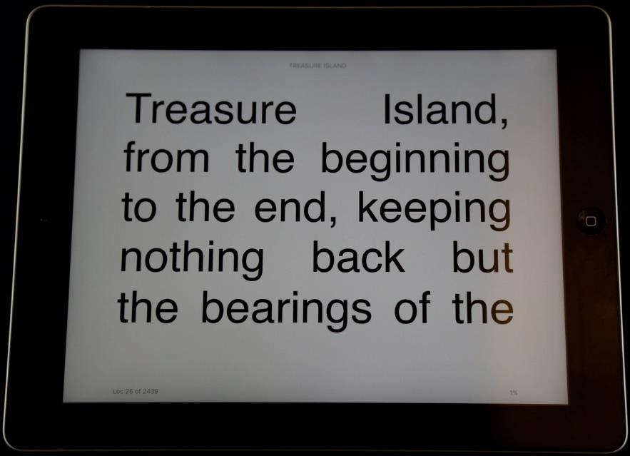

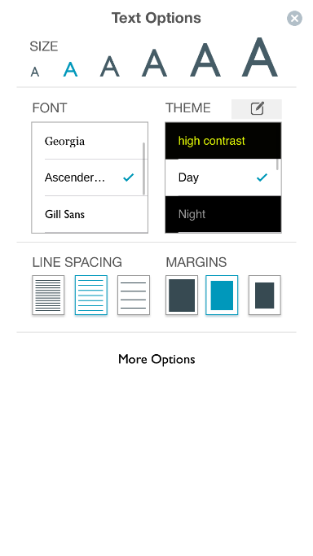

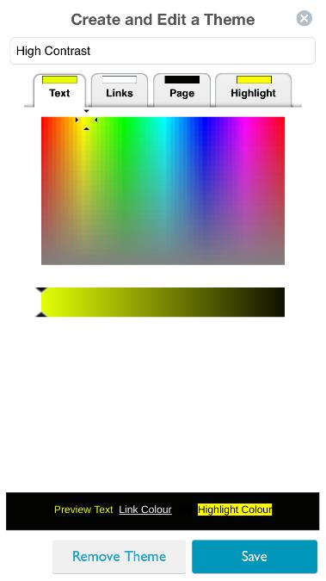

The image below is from an Apple iPad screen showing the Amazon Kindle App at maximum size text, which equates to approximately 54pt size text.

Dyslexia

This category of users is the largest, with current estimates of around 1 in 10 people having some form of dyslexia, but it is also the most diverse and reading requirements within this group vary significantly. Generally considered a learning difficulty rather than a disability, dyslexia is characterised by trouble reading, and can also include difficulties spelling and writing. Users with dyslexia benefit from customising the typeface, text size, controlling the space between words, line spacing, as well as reducing the contrast between the text and background and changing their colours. Some people with dyslexia also benefit from audio versions of the text, sometimes synchronised with highlighting of the text itself to help individuals follow along as the text is voiced.

The images below from the Nook Reading System on iOS show the presentation customisation settings offering control over text size, typeface, layout and colour.

5

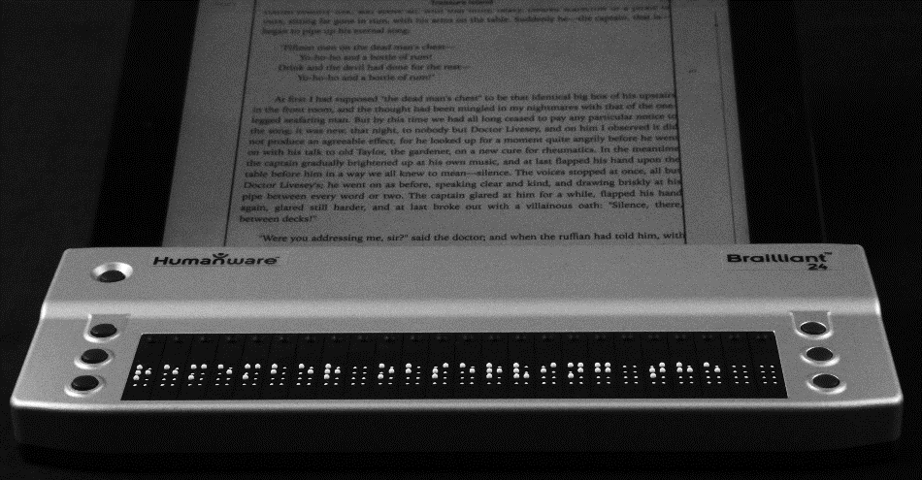



Blindness

For people who have no functional vision, the text of the book needs to be rendered in an alternative format. Audio is probably the most common solution and many modern touchscreen phones and tablets are capable of switching to a gesture based user interface and generating natural sounding synthetic speech.  The gesture controls can then be used to read and control an eBook. The same technology can also be used to convert text into the raised dot format braille. A specialist electronic braille display can be connected wirelessly, containing a series of pins which raise and lower to create letters and words in the tactile format. Additional buttons on the device can also be used to navigate the document.

The image below shows a portable refreshable braille display, which is connected wirelessly to an Apple iPad mini to show in braille exactly what is displayed on the screen in Apple iBooks.

Physical disabilities

People with physical disabilities are also able to enjoy accessing text through eBooks when they might otherwise be unable to hold a book or eBook reading device or may not have the fine motor skills to turn a page or push buttons on a conventional device. Computers, tablets and phones can be controlled through a variety of customisable physical switches, gesture based controls or even eye tracking allowing someone with limited mobility to navigate through an eBook.

6

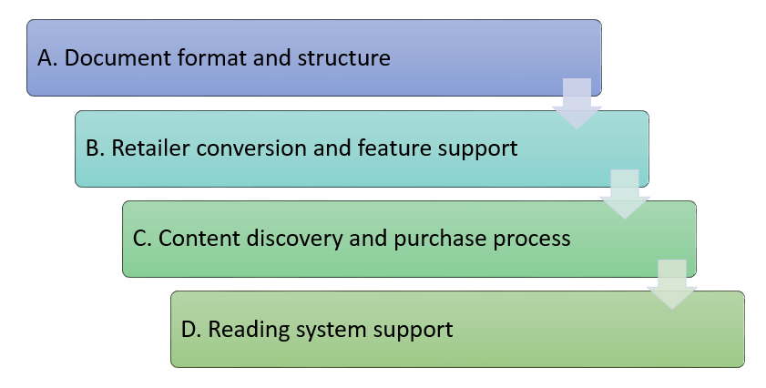

3. Factors which influence eBook accessibility

EBook accessibility is a fairly complex topic, with many opportunities at each stage in the process for best intentions to go awry before an accessible publication can be enjoyed by an individual who would otherwise be unable to access a conventional publication.

The area is so multifaceted that this document will not attempt to cover everything but it will highlight the key topics for authors to make decisions and further enquiries with the retailers. While many other parties have roles to play in ensuring a publication reaches and can be accessed by an individual with disabilities, the primary responsibility rests with the author. Without due consideration and appropriate action, the process of making a publication accessible is unlikely to succeed.

The chart below, which is described in the following paragraph, summarises the stages in the self-publishing process which have accessibility implications.

The outcome of an eBook being accessible to an individual with print disabilities relies on a number factors including:

A.  A well-prepared source document which is appropriately formatted and well-constructed to support accessibility features. This is typically a word processed document but may be converted to an eBook format.

B.  Quality ingestion of the content by a Retailer to create a user-ready eBook which supports accessibility and preserves the features of the source manuscript. This can include conversion to an eBook format or simply processing of a submitted eBook.

C.  An accessible retail environment where users can find or choose a book and then complete a purchase or loan process to obtain the eBook they have selected in an appropriate format.

D.  A Reading System (hardware, software or App) which supports accessibility, and specifically the accessibility requirements of the user. This might also include the option for specialist third party hardware or software to enable access (like a braille display or switch controls).

Clearly, not all of these factors can be affected by an author looking to self-publish. However, the decisions made at the start of the publication process can make the difference between an eBook which cannot be read by people with print disabilities and one which has the potential to be fully accessible and enjoyed by everyone.

7

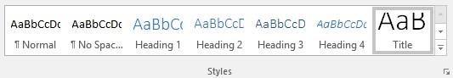

4. Constructing an accessible source document

The optimum route to an accessible eBook starts with the creation of a source text which is well structured and contains the appropriate information to facilitate accessibility. In most cases, this is actually a fairly straightforward process which can be achieved in all of the common word processing applications. In addition, this process is recommended by most of the companies supporting and offering self-publishing, including the retailers.

This is because the retailers perform an automated conversion of the submitted manuscript to an eBook format and even manuscripts submitted in an eBook format will be automatically analysed and modified to work within their system.

Conversion of any electronic document between formats will at best only preserve the content and features of the original document but, in many cases, it is a subtractive process with some information being lost in the transition. In most cases, this information is not essential to the resulting eBook. The process is very rarely additive, especially when it comes to accessibility in self-published eBooks, since the process is fully automated, the end result being that your publication will only be as accessible as you choose to make it through the construction of an accessible source manuscript.

Applying Styles

Document structure is achieved by formatting text using styles instead of character formatting. One example is, when adding a chapter title, it is possible to increase the font size and make it bold but this does not inform the document or the user that this is a chapter title. The more accessible and usable solution is to apply a Styled Heading Level, which enables the generation of an automated table of contents and, more importantly, allows people to navigate the document to that chapter and, once there, be able to identify their location.

Styled headings are easy to apply and come with some very simple rules: always apply styles consistently – so, if you use Heading Level 1 for a chapter heading, all chapter headings should use Heading Level 1. Heading levels should be applied in sequential order – for example, Heading 1 for chapter titles, Heading 2 for sub-section titles, and Heading 3 for the next section within that.

Additional styles should be used for quotes, captions and even customised styles can be created and, although only heading level styles are essential for accessibility, you will benefit from consistent layout and design by using styles throughout your document.

8

Character formatting

When it comes to document formatting, many people are familiar with the menu options on their word processor which allow changes to font size, typeface, colour or to make the text bold, underlined or italicised. This character formatting can make the document more visually appealing.

However, it is important to be aware that it typically conveys little or no information in an accessible document and can, in some cases, hamper accessibility.

When large expanses of text are formatted to be bold or italics, it can be difficult for some users, like people with dyslexia or low vision, to read. So when character formatting is used, it should be applied sparingly. Because the formatting information is typically not conveyed in formats like audio and braille, it should not be used in isolation to convey information.

Image accessibility

All of the eBook formats support the option to include images and, while many readers will benefit from the inclusion of graphics, they can prove challenging from an accessibility perspective.

When adding an image to an eBook, it is important to remember that it will be displayed differently on the range of different reading systems people can use to read your eBook. The size of the screen can vary significantly making a potentially clear image on a large screen much more challenging to read on a smaller device. Also e-Ink devices capable only of greyscale will lose any colour information in your image.

EBooks which are rendered as audio or braille will not be able to include any images but can instead incorporate a description of the image. Image descriptions can be added to an image as a caption or inserted into the image metadata as an alternative textual description known as alt text. Alt text can be inserted when the image is added to the document or at any time through the image properties.

Some word processing applications allow both a title and a description field for image alt text, whereas other applications have just a single field. Depending on the word processing application and the chosen retailer, the content of both, one or neither of the alt text fields may be retained. For the best results, a single field should be used consistently and the images should be checked throughout the conversion process to ensure that the alt text has been preserved and not placed below the image or completely removed.

Not all images need to be made accessible and, as a simple guide, only those images which convey key information not already described should have an alternative description. This means any purely decorative images do not need to be described and, if an image is adequately described in a caption, it does not need to be repeated as alt text. Where an image is displaying information where people might reasonably be expected to draw a conclusion, it is best to include that conclusion in the alt text. For example, “Chart of coffee sales for 2015 showing a gradual increase in sales throughout the year” or “map of an island with a red X in the south west near a church”.

Because the alt text should be written to reflect the context of its use, images do not typically have a single description that will work in all settings, as shown in the following examples.

9

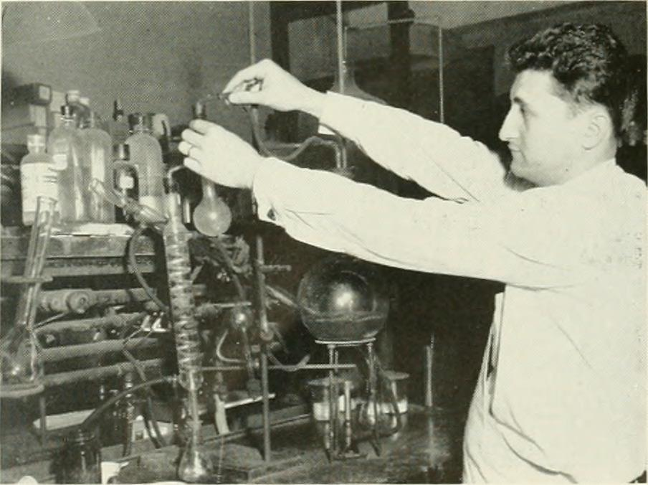

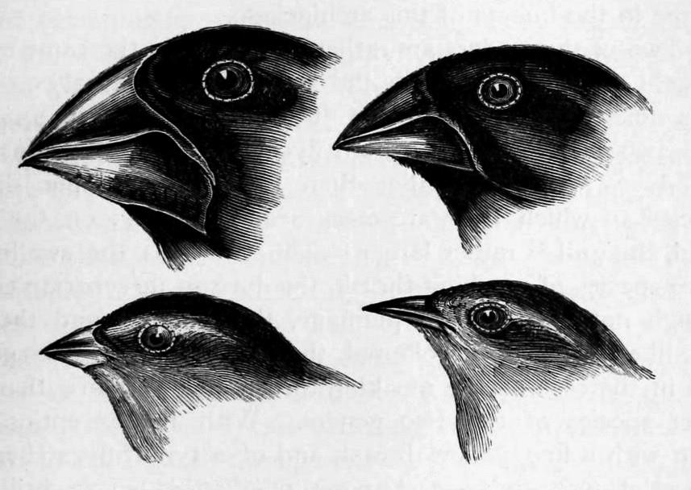

The chemistry example above could have any of the following alt text descriptions:

•  Photograph showing 1950 chemistry safety procedure of working with extended arms.

•  Photograph of a chemist working with laboratory equipment.

•  Photograph showing chemistry in police testing for alcohol in 1957.

The bird illustration image above could have any of the following alt text descriptions:

•  Four hand drawn illustrations of bird heads.

•  Illustrations of Finch heads from the Galapagos Archipelago by Charles Darwin.

•  Drawings showing the differences in beak size of Finches from the Galapagos Islands.

Based on the context of the surrounding text, any of the descriptions above would be valid. When writing your alternative description consider how it fits within the surrounding text and what information is conveyed through the image alone. If you leave a learning objective for people to conclude from viewing the image, you will need to convey that succinctly in the alt text. Where an 10

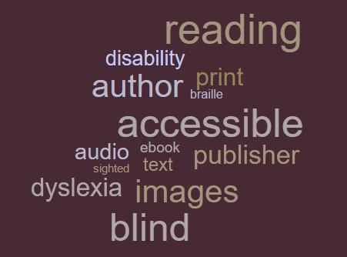

image is added to reinforce the message, the full message does not need to be repeated and a brief description of the image title can be added instead.

Currently, even though all of the eBook formats support the inclusion of alt text, not all eBook reading systems support their use which means your descriptions may not be available to the reader.

Alt text is still the most appropriate solution for image descriptions but, to guarantee the availability of the description to users accessing your eBook in an accessible format, it is currently best to ensure your learning objectives are encompassed within the text of your publication.

Links to further advice and examples on the content of image descriptions can be found in the Other

Resourcessection of this guide.

Text as graphics should be avoided

One of the biggest challenges in text accessibility is when creators highlight words by designing them into an image. This is very common in social media, producing an image with a few words and a background image or a word cloud of key points.

The image below demonstrates the bad practice of a word cloud which will not produce any accessible text.

In eBooks this can also include design features like dropped capitals at the start of a chapter.

Wherever possible, text should be preserved as text throughout your document and, where it is necessary as an image, necessary steps should be taken tomake that image accessible.

Avoid using tables

Information laid out in a tabular form can be a very effective way to visually show the relationships between data elements and enable detailed analysis of the content. In an eBook, tables can present serious issues, especially when the text size is enlarged or displayed on the small screen of a mobile device and the entire table does not fit within a single page. In addition, some methods of navigating tables with access technology make it difficult to relate a specific cell to the row or column headings, which makes using a table a complex and incredibly challenging memory game. To make tabular data as accessible as possible, try to keep any tables small, perhaps using multiple tables instead of a single large one. Where possible, you might want to consider describing the relationship and trends within the data, making navigation of the table less critical.

11

5. Introduction to eBook formats and accessibility support The notion of packaging books electronically for delivery has been with us for a while and, over 10

years ago, many companies wanted to develop their own solution as the format of choice with more than 20 format options available. Over time, the number of options has reduced to just 2 main formats: EPUB and Kindle. It is important to note that, simply because an eBook format has the capability of supporting accessibility, it does not automatically make content accessible. Outside of the mainstream eBook formats for self-publishing, there remain a few alternatives which are also highlighted.

EPUB

EPUB is the leading format in the digital publishing sector and was developed as an open standard by the industry for anyone to use. It is the format of choice for the majority of eBook publishers, reading systems and eBook retailers. EPUB3, the latest version of the standard, was developed to meet the needs of modern mainstream publishing but also had accessibility in mind from the outset.

Throughout the development process, consideration was given to how all the features could be made accessible to people with print disabilities. The result is an eBook format which has the potential to contain and deliver complex content in a completely accessible way and, as a result, the format has been endorsed by publishing and disability organisations globally as the best way to publish.

Kindle

The Kindle format or, more accurately, collection of formats, are based on a closed standard from Amazon and the Amazon Kindle eBook environment is the only retailer to use these formats.

Because the specification for the format is not made public, it is not as simple to assess for accessibility. However, it is clear that improvements in accessibility have been made over time.

A well-constructed conventional book which is text driven has the potential to be fully accessible in the Kindle format. The format also has the potential to support image accessibility, but the Kindle reading systems do not currently support the information (alt text) required to make images accessible.

Adobe PDF

The PDF format was developed to preserve the visual layout of documents across devices. PDF as a format has changed over time and now PDF documents can support accessibility. It is important to note that creation of an accessible PDF document does not happen automatically in any conversion or export function, and the conversion to other accessible formats remains challenging. As a result, PDF is not recommended as an intermediary format for submission to eBook retailers.

EBooks as dedicated Apps

It is possible to develop an eBook into a dedicated App for sale on a mobile platform. All of the major platforms (e.g., iOS, Android) support accessibility and it is possible to create a fully accessible App to run on these platforms. Guidelines on accessible App development are available from all the platforms and care should be taken to ensure any App developer or service offering conversion follows the recommended guidelines to produce an App of the required accessibility.

12

6. Accessibility in self-publishing retailers

The level of accessibility support varies significantly in different self-publishing channels, with most of the major companies having made some considerations towards accessibility support but not necessarily across all of their platforms or to meet the requirements of all the print disability groups.

The number of global routes to self-publishing makes it challenging to provide a comprehensive review of all the available options. Instead we can look at some of the larger companies to explore the options and the complexity which surrounds them.

It is important to note that the eBook sector is highly competitive, with regular updates issued to improve the conversion and delivery of publications, as well changes to improve the reading systems people use. All the self-publishing channels highlighted have additional information on their websites to describe the features they support and the recommended format for your manuscript. It is recommended that authors search for the latest website updates and then contact the relevant companies to ask any specific questions they may have.

This guidance does not cover the user experience of finding and purchasing a title for each retailer, primarily because this can vary significantly depending on the requirements of the individual, the technology they use (specialist or otherwise), and even their geographic region. If you are interested, you may want to ask your preferred retailer about the accessibility of their content discovery and purchase experience.

Amazon Kindle Direct Publishing

<https://kdp.amazon.com/>

EBook format and features

EBooks published through the Amazon Kindle service use the Kindle eBook format. Behind the scenes technically, there are several Kindle formats which offer a variety of features, with periodic updates to the format to add new features and ensure the documents can be read across their portfolio of Reading Systems.

KF8 is the latest generation of Kindle format and recent updates have enabled support for embedded video, audio and animations. The Kindle Direct Publishing programme can accept these highly technical eBooks. However, it is primarily focused on conventional novels and the guidance available on the site is focused on these traditional and more straightforward publications.

Kindle is capable of supporting basic accessibility for conventional novels, primarily related to the presentation and navigation of structured text. Image accessibility, and the accessibility of more complex content like mathematical equations, video or interactivity are not currently supported.

Accessibility advice

Amazon does not offer any specific accessibility advice to authors or eBook creators. The general guidance offered by Kindle recommends that manuscripts should be kept as simple as possible, using only very basic formatting, all of which is in line with accessibility recommendations.

Reading System accessibility

Amazon has done a considerable amount of work to make its reading systems accessible to people with print disabilities, with options throughout their range supporting the needs of people who read through braille, audio, enlarged text or require customised colours. With a diverse range of reading options available on desktop computers through to dedicated e-Ink displays like the Kindle 13

Paperwhite, limitations on devices prevent the full range from supporting all accessibility features (e.g., you will not get colour customisation options on a black and white e-Ink display) but, where practical, accommodations appear to have been made. Of particular note are the Kindle Fire and Kindle iOS Apps, both of which have extensive support for accessibility.

Kindle supports (in at least one Reading System):

•  Audio

•  Braille

•  Colour customisation (limited)

•  Layout and typeface customisation

Issues and workarounds

At present Kindle does not support image accessibility through alternate text descriptions (alt text), and no guidance is offered on the topic. There are, however, signs in some of their publishing tools that this feature may be supported in the future. To make the most accessible Kindle eBook, consider using captions below any images to describe the image content and convey any learning objectives.

Apple iBooks

<http://www.apple.com/itunes/working-itunes/sell-content/books/>

EBook format and features

iBooks uses the EPUB format to deliver and display eBooks and support for the various features of EPUB is quite extensive, encompassing functionality for technical publications, interactive elements, multimedia resources and early years literacy. There are, however, limitations for authors who do not use Apple computers. All manuscripts need to be submitted through the free iTunes Producer application for Apple computers, which is available to Mac users after signing a contract through iTunes Connect. Files can then be submitted in iBooks Author format (.iBooks), or as a valid EPUB 3

eBook. iBooks Author is also a free application for Apple computers.

Accessibility advice

Apple has been at the forefront of adopting accessibility features in the EPUB format and has supported those features in their eBook designing tool iBooks Author, actively enabling accessible output from all the default options.

Third party guidance is available to support people creating accessible eBooks using iBooks Author and more general accessibility advice is available from Apple.

Reading system accessibility

Apple iBooks is generally considered to be one of the most accessible reading environments, with iBooks on the iPhone and iPad being very accessible. The presentation options on iBooks are generally much more limited than other reading systems and may be restricting for people who need to read using a specific colour combination or certain typeface to read.

The range of Reading Systems is also much more limited than all of the eBook Retailers, with the iBooks Reading System only available for Apple computers and devices (iPod Touch, iPhone and iPad).

14

iBooks supports (in at least one Reading System):

•  Audio

•  Braille

•  Colour customisation (limited)

•  Layout and typeface customisation (limited)

Issues and workarounds

Fixed layout publications have become popular in iBooks to control and preserve the layout throughout the document. Creating eBooks with fixed layout will severely limit the accessibility of your publication for people who need to enlarge the text or change the presentation options and, as a result, this feature should be avoided.

Many third party plug-ins (widgets) are available for iBooks Author to enhance and add options for complex content. However, many of these developments will not have considered accessibility and could, as a result, make your publication less accessible. It is therefore recommended that authors ask third party developers about the accessibility of the output from their widgets or limit their widget use to the default options.

Barnes & Noble Nook Press

<https://www.nookpress.com/ebooks>

EBook formats and features

Nook uses the EPUB format to create and deliver their eBooks, although no prior experience of the format is required as manuscripts can be uploaded in all the common word processing formats and then edited and proofed in their online tools. EPUB supported by Nook offers all the primary features to enable a fully accessible novel, with more advanced features available for people creating and submitting a publication-ready EPUB3 file.

Accessibility advice

No specific advice on eBook accessibility for authors is offered by Nook, although they do offer guidance on manuscript formatting which is in line with accessibility good practices.

Reading System accessibility

The development team at Nook have clearly invested time in exploring the accessibility options for their Reading Systems and implementing the features where possible. As a result, Nook offer some of the most complete reading experiences for people with print disabilities, especially on mainstream mobile devices (iOS and Android) which are a beacon of good practice. Of particular note is the extensive range of colour customisation options, allowing people to fully customise the presentation of the eBook on screen, and the on-device tutorial which is automatically provided to people using speech technology when accessing for the first time.

Nook supports (in at least one Reading System):

•  Audio

•  Braille

•  Colour customisation

•  Layout and typeface customisation

15

Issues and workarounds

The Nook Press online manuscript editor does not currently support alt text for images, requiring images to have descriptive captions for accessibility instead.

Kobo Writing Life

<https://www.kobo.com/writinglife>

EBook formats and features

Kobo also uses the EPUB format to deliver its eBooks and supports a range of features that come with the format, although the Kobo publications are focused primarily around conventional eBooks with structured text and images. Manuscripts can be submitted in the common word processor formats, as well as EPUB and MOBI files.

Accessibility advice

Kobo offers no accessibility advice and only limited guidance on document preparation and layout, although the information offered on formatting is in line with accessibility good practices.

Reading system accessibility

Kobo offers a range of reading systems across all the common platforms, as well as dedicated e-Ink and colour tablet hardware. While the Kobo range does support a good range of text sizes and some presentation customisation options, overall the Kobo Reading Systems have limited accessibility support, with no support for reading through audio or through connected braille displays.

Kobo supports (in at least one Reading System):

•  Colour customisation

•  Layout and typeface customisation

Issues and workarounds

Because the eBook format supported by Kobo is fully featured and any accessibility challenges sit with the Reading Systems, it is recommended that manuscripts submitted to Kobo continue to follow the best practice recommendations and the no workarounds should be implemented. This allows the most accessible eBooks to become available when Kobo does make its Reading Systems more accessible.

7. Accessibility challenges

The possibilities offered in modern eBook publishing are truly expansive, with support for a wide variety of content beyond conventional text. For many of these new content types methods have been identified to enable accessibility support, primarily in the EPUB3 format, but some of these potential solutions remain theoretical in nature and are not currently practiced. If you are planning to add any of these features to your eBooks, it is recommended that you conduct additional research and seek further advice on making them accessible.

Complex content

If the content of your publication extends beyond text in a single language, additional work may be required to add metadata and encode the complex content. Support for scientific notation like chemistry and complex mathematical equations is supported in some eBook formats like EPUB3 and has the potential to be fully accessible. These will not be converted automatically from word processing applications and will require work to edit into the converted eBook document. Equally, 16

text which is in multiple languages can also be made accessible with additional effort in the eBook creation process, to ensure the content is rendered properly especially in braille and audio.

Interactivity

The addition of interactivity in eBooks has been likened to a move away from conventional publishing and closer to packaging a webpage into a standalone document which, in many ways, is an accurate description since many of the same technologies are utilised in both arenas. Interactivity in eBooks allows authors to insert tests, puzzles and games into their eBooks. It also allows books to become more interactive, with a book adjusting to reference information provided by the user, for example, changing the name of the princess in a child’s story book. These types of eBook are in their infancy and, as a result, often require advanced eBook creation skills to create and they should follow the industry guidance for good practice in eBook creation and web development to ensure accessibility requirements are met.

Multimedia

It is also possible to embed video, audio and animations into an eBook. Once again, this is a fairly complex procedure but it is technically possible to make multimedia fully accessible, typically by providing an alternate version of each type of media (e.g., a video with additional descriptions for people with sight loss, along with captions or a text transcript for people with hearing loss).

8. Additional Considerations

Digital Rights Management

The system designed to protect eBooks from unauthorised copying, Digital Rights Management, restricts the devices or reading systems on which an eBook can be opened. This technical protection measure does not always impact the accessibility of the eBook but, on occasion, can prevent access by specialist software. If the retailer selling the eBook has created a suite of accessible reading systems, one of those options may present a suitable solution. Where a retailer does not provide an accessible reading system and the Digital Rights Management technology prevents an eBook from being read on an accessible reading system developed by a third party, the protection system then becomes a barrier to access. To reduce the impact that Digital Rights Management might have on accessibility, authors should publish with a retailer that offers a wide range of accessibility support in their reading systems.

Fixed layout

Some titles with rich imagery and complex layout can struggle with the more fluid layout of an eBook, which is typically designed to reflow as the text changes size to fill the page. The new EPUB3

format offers more support to complex layouts which require a higher level of design control when displayed on different screen sizes and need to adjust that presentation when text is resized. This technology is at an early stage and the alternative suggestion is to lock down the presentation of the book to ensure a strong visual design. While this may be visually appealing to some, it presents a series of accessibility barriers to people who need to enlarge or customise the presentation of the text. To improve accessibility, eBooks should not be locked to a fixed layout.

17

9. Checklist of accessibility considerations when self-publishing To help summarise some of the key messages in this guide, the following checklist of considerations has been developed as you progress the self-publishing process.

EBook technologies offer a life-changing opportunity for people with print disabilities to access publications they may otherwise never be able to read. By considering accessibility in the creation of your publication, you not only enable people with print disabilities to access your work, you open up opportunities for a much wider readership to buy and enjoy your creation.

1. Document formatting:

o  Is your source document formatted with Styled Heading Levels?

o  Are Heading Levels applied consistently throughout the document?

o  Is Character Formatting minimal and not used to convey essential information?

o  Do all Images conveying information have captions and/or alt text?

o  Are any Tables used small and any key trends described in the text?

2. EBook format choice

o  Is your choice of eBook format capable of supporting an accessible version of your publication?

3. Self-publishing retailers

o  Does your chosen publishing retailer support the level of accessibility required for your publication?

o  Are you happy that the Reading Systems offered by your chosen retailer provide an appropriate level of accessibility?

o  Have you reviewed the guidance provided by your retailer?

4. EBook challenge areas

o  Has assistance been sought for complex content, multimedia or interactivity?

o  Is any multimedia also offered in alternate accessible formats to support people who cannot see or hear it?

o  Will Digital Rights Management present an accessibility barrier for your chosen vendor?

o  If you are interested in publishing a fixed layout title, are you fully aware of the accessibility limitations and implications of your choice?

5. Find out more

o  Did you explore the additional resources in the further information section?

o  Have you checked with your chosen retailer about latest developments in the accessibility of their service and reading systems?

18

10. Glossary of terms

Alt text – An alternative textual description commonly applied to images, designed for people who are unable to access the original visual image, when the alt text can be played in audio.

Author Publisher – The person who created the original Work which they would like to publish and, in this process, also the person who has a relationship with an eBook Retailer to make the book available.

eBook Retailer – The technology company which establishes a formal relationship with the Author Publisher, accepting their Work in a digital form, automatically converting it and making it available through their eBook shop.

Intermediaries – Optional third party organisations which offer to work for the Author to process and submit their Work to an eBook Retailer, managing the technology and assisting with the legal relationship.

Mark-up – Encoding of a document which provides additional information typically used to control the presentation of document elements.

Print Disability – Term encompassing all people with a disability which prevents them from reading conventional publications, encompassing a diverse range of physical, sensory and cognitive disabilities.

Reading System – Because the term “eBook reader” can confusingly refer to both a user and the piece of technology rendering an eBook, the industry has adopted the term Reading System to reference a tool used to access and navigate the eBook. This could be a conventional piece of software for a desktop computer, an App for a smart phone or tablet or a dedicated piece of technology. All the major Retailers have their own dedicated Reading Systems which have to be used to access their eBooks.

User – The customer of the Retailer who buys the eBook and reads it on their Reading System of choice. In the context of this document the user is a person with a print disability, and the Reading System may need to have special qualities for the eBook to be accessible.

Work – The book content or intellectual property created by the author.

19

11. Further resources

Accessible Publishing

Accessible Books Consortium

<http://www.accessiblebooksconsortium.org/>

Manuscript Document Formatting

WebAIM guidance creating accessible Word documents:

<http://webaim.org/techniques/word/>

Microsoft Style basics in Word:

[https://support.office.com/en-us/article/Style-basics-in-Word-d382f84d-5c38-4444-98a5-](https://support.office.com/en-us/article/Style-basics-in-Word-d382f84d-5c38-4444-98a5-9cbb6ede1ba4)

[9cbb6ede1ba4#](https://support.office.com/en-us/article/Style-basics-in-Word-d382f84d-5c38-4444-98a5-9cbb6ede1ba4)

Libreoffice Writer Guide(PDF):

<https://wiki.documentfoundation.org/images/e/e6/WG42-WriterGuideLO.pdf>

OpenOffice Writer guide (PDF):

<http://www.openoffice.org/documentation/manuals/userguide3/0200WG3-WriterGuide.pdf>

Image descriptions

Digital Image and Graphic Resources for Accessible Media (DIAGRAM):

<http://diagramcenter.org/>

W3C Web Accessibility Tutorial on image:

<http://www.w3.org/WAI/tutorials/images/>

W3C Alt text decision tree:

<http://www.w3.org/WAI/tutorials/images/decision-tree/>

Reading System Accessibility

EPUB 3 support on reading systems, including some accessibility tests:

<http://www.epubtest.org/>

RNIB Video of Kindle Fire HD accessibility features:

<https://www.youtube.com/watch?v=fquYkkmbFgQ>

EBook format accessibility

IDPF EPUB3 Accessibility Guidelines:

<http://www.idpf.org/accessibility/guidelines/>

Kindle Format 8:

<http://www.amazon.com/gp/feature.html?docId=1000729511>

Creating accessible PDF files (PDF):

<https://www.adobe.com/enterprise/accessibility/pdfs/acro6_pg_ue.pdf>

20

Accessibility for iOS Developers:

<https://developer.apple.com/accessibility/ios/>

Accessibility for Android Developers:

<http://developer.android.com/guide/topics/ui/accessibility/index.html>

Manuscript formatting

Nook MS Word formatting advice:

<http://www.nook.com/services/cms/doc/nookpress/gb/en_gb/faq/formatting-guidelines-word.html>

Kindle publishing guidelines (PDF):

<https://kindlegen.s3.amazonaws.com/AmazonKindlePublishingGuidelines.pdf>

Apple iBooks Author: How to make your books accessible:

<https://support.apple.com/en-us/HT202371>

Apple Creating Accessible iBooks Textbooks with iBooks Author (free iBooks publication):

<https://itunes.apple.com/us/book/creating-accessible-ibooks/id569179589?mt=13>

Kobo Writing Life User Guide (PDF):

<http://download.kobobooks.com/writinglife/Kobo/en-US/KWL-User-Guide.pdf>

Kobo Writing Life FAQ (PDF):

<http://download.kobobooks.com/writinglife/Kobo/en-US/KWL_FAQ.pdf>

Kobo Writing Life Content Conversion Guidelines (PDF):

<http://download.kobobooks.com/writinglife/en-US/KWL-Content-Conversion-Guidelines.pdf>

12. Image credits

The images that appear in this guidance are licenced as follows. References appear in order of presentation.

•  iPad showing large print Treasure Island – created by Dave Gunn, licenced under Creative Commons Attribution 4.0 International

•  Nook on iOS screen captures – created by Dave Gunn

•  Refreshable braille display photo – created by Dave Gunn, licenced under Creative Commons Attribution 4.0 International

•  Photo of man in wheelchair – under standard licence fro[m Shutterstock](http://www.shutterstock.com/)reference 25994161

•  Chemistry image – from page 34 of “Annual report of the Police Commissioner for the City of Boston”. Book available on[Archive.org,](https://archive.org/stream/annualreportofpo58bost/annualreportofpo58bost#page/33/mode/1up)image available o[n Flickr](https://flic.kr/p/odXGpE)– identified as having no known copyright restrictions.

•  Illustrations of Finches – from page 442 of "Journal of researches into the natural history and geology of the countries visited during the voyage round the world of H.M.S. 'Beagle,' under the command of Captain Fitz Roy" (1913). Book av[ailable on Archive.org, imag](https://archive.org/stream/journalofresear01darw/journalofresear01darw#page/405/mode/1up)e available on

[Flickr](https://flic.kr/p/ouT3k7)–  identified as having no known copyright restrictions.

21

# Document Outline

* Foreword
  + Statement from the Alliance of Independent Authors:
* Disclaimer
* Table of contents
* 1. What is eBook accessibility? 
  + Key terms in the process
* 2. How eBook accessibility works and for whom
  + Visual Impairment
  + Dyslexia
  + Blindness
  + Physical disabilities
* 3. Factors which influence eBook accessibility
* 4. Constructing an accessible source document
  + Applying Styles
  + Character formatting
  + Image accessibility
  + Text as graphics should be avoided
  + Avoid using tables
* 5. Introduction to eBook formats and accessibility support
  + EPUB
  + Kindle
  + Adobe PDF
  + EBooks as dedicated Apps
* 6. Accessibility in self-publishing retailers
  + Amazon Kindle Direct Publishing
    - EBook format and features
    - Accessibility advice
    - Reading System accessibility
    - Issues and workarounds
  + Apple iBooks
    - EBook format and features
    - Accessibility advice
    - Reading system accessibility
    - Issues and workarounds
  + Barnes & Noble Nook Press
    - EBook formats and features
    - Accessibility advice
    - Reading System accessibility
    - Issues and workarounds
  + Kobo Writing Life
    - EBook formats and features
    - Accessibility advice
    - Reading system accessibility
    - Issues and workarounds
* 7. Accessibility challenges
  + Complex content
  + Interactivity
  + Multimedia
* 8. Additional Considerations
  + Digital Rights Management
  + Fixed layout
* 9. Checklist of accessibility considerations when self-publishing
* 10. Glossary of terms
* 11. Further resources
  + Accessible Publishing
  + Manuscript Document Formatting
  + Image descriptions
  + Reading System Accessibility
  + EBook format accessibility
  + Manuscript formatting
* 12. Image credits